PHYS 123, Lab 6 Questions

**Name**: Markiyan Varhola

**CWID**: A20324717

1. Answer the following questions using the data you acquired in this experiment:

*(a) For the first experiment, create a data table for the different masses (M1, M2), the acceleration, and the calculated coefficient of friction µk. Remember to label the cart types (felt, cork, plastic) in your table and describe the surface.*

|  |  |  |  |  |  |  |  |
| --- | --- | --- | --- | --- | --- | --- | --- |
| **Surface** | **Cart Type** | **M1** | **M2** | **a (trial 1)** | **a (trial 2)** | **a (avg)** | **uk (coefficient of friction)** |
| Paper | Felt | 580.4 | 210 | 0.06 | 0.07 | 0.07 | 0.35 |
|  |  | 580.4 | 260 | 0.47 | 0.51 | 0.49 | 0.38 |
|  |  | 580.4 | 310 | 1.04 | 1.01 | 1.03 | 0.37 |
|  | Plastic | 580.4 | 210 | 0.66 | 0.61 | 0.64 | 0.27 |
|  |  | 580.4 | 260 | 0.99 | 1.14 | 1.07 | 0.29 |
|  |  | 580.4 | 310 | 1.57 | 1.64 | 1.61 | 0.28 |
| Table | Felt | 580.4 | 210 | 0.72 | 0.69 | 0.71 | 0.26 |
|  |  | 580.4 | 260 | 1.25 | 1.24 | 1.25 | 0.26 |
|  |  | 580.4 | 310 | 1.64 | 1.62 | 1.63 | 0.28 |
|  | Plastic | 580.4 | 210 | 1.06 | 1.09 | 1.08 | 0.21 |
|  |  | 580.4 | 260 | 1.62 | 1.58 | 1.6 | 0.21 |
|  |  | 580.4 | 310 | 1.84 | 1.88 | 1.86 | 0.24 |

*(b) Do your measured values of µk make sense? Compare them with sample coefficients of friction (for various materials) found in your textbook.*

The values make sense, as felt on paper experiences greater friction than felt on a table, due to the smoothness of the surface. The values were compared to those found in a textbook, and look to be fairly accurate.

*(c) For the second experiment, what is the force that you are measuring? Create a plot of this measured force vs the normal force of the friction cart. Find its slope and explain what it represents.*

We are measuring the force that it takes to pull the object away, therefore it would be the frictional force.

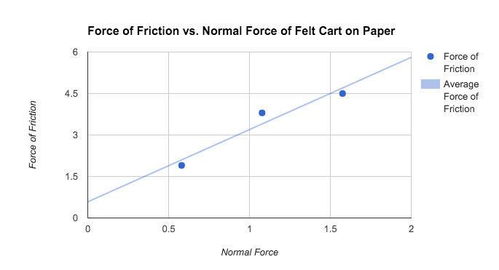  
The slope of this graph is 0.33, which is the same as the coefficient of static friction.

*(d) For the third experiment, make a data table consisting of the cart masses, any applied force,*

*and the normal force. Using your data, create a graph that represents the coefficient of friction.*

|  |  |  |  |  |  |
| --- | --- | --- | --- | --- | --- |
| **Surface** | **Cart Type** | **M1** | **Force (kinetic)** | **u (kinetic)** | **u (kinetic) (avg)** |
| Paper | Felt | 580.4 | 1.7 | 0.3 | 0.29 |
|  |  | 1078 | 3.2 | 0.3 |  |
|  |  | 1575.6 | 4 | 0.26 |  |
|  | Plastic | 580.4 | 0.9 | 0.16 | 0.16 |
|  |  | 1078 | 1.7 | 0.16 |  |
|  |  | 1575.6 | 2.5 | 0.16 |  |
| Table | Felt | 580.4 | 1.2 | 0.21 | 0.21 |
|  |  | 1078 | 2.2 | 0.21 |  |
|  |  | 1575.6 | 3.1 | 0.2 |  |
|  | Plastic | 580.4 | 1 | 0.18 | 0.16 |
|  |  | 1078 | 1.6 | 0.15 |  |
|  |  | 1575.6 | 2.4 | 0.16 |  |

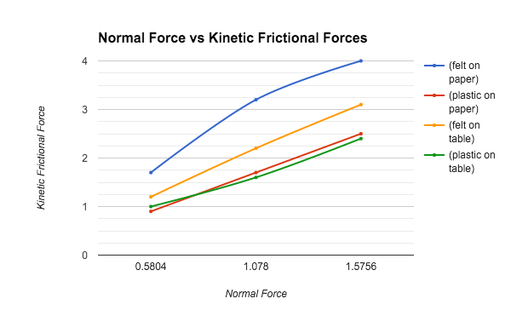

*(e) How does your coefficient of friction from the third experiment compare with the one you*

*obtained from the first experiment? What are the sources of error?*

The coefficients of friction from the third experiment are slightly smaller than our values from the first experiment. This is most likely due to the accuracy of the measuring device, as it had a limited poll rate. Also, to make the measurements more accurate, the force would have to be applied at a steadier rate, meaning that a person would have to pull the objects at a steady speed over a longer distance.